Ideation Phase
Define the Problem Statements

Date | 17-12-2025
Team ID
Project Name | Video Conferencing App
Maximum Marks | 2 Marks

Customer Problem Statement Template:
To define the core problems user’s face while using online meetings and conferencing tools, and use those insights to guide the development of Video Conferencing App.
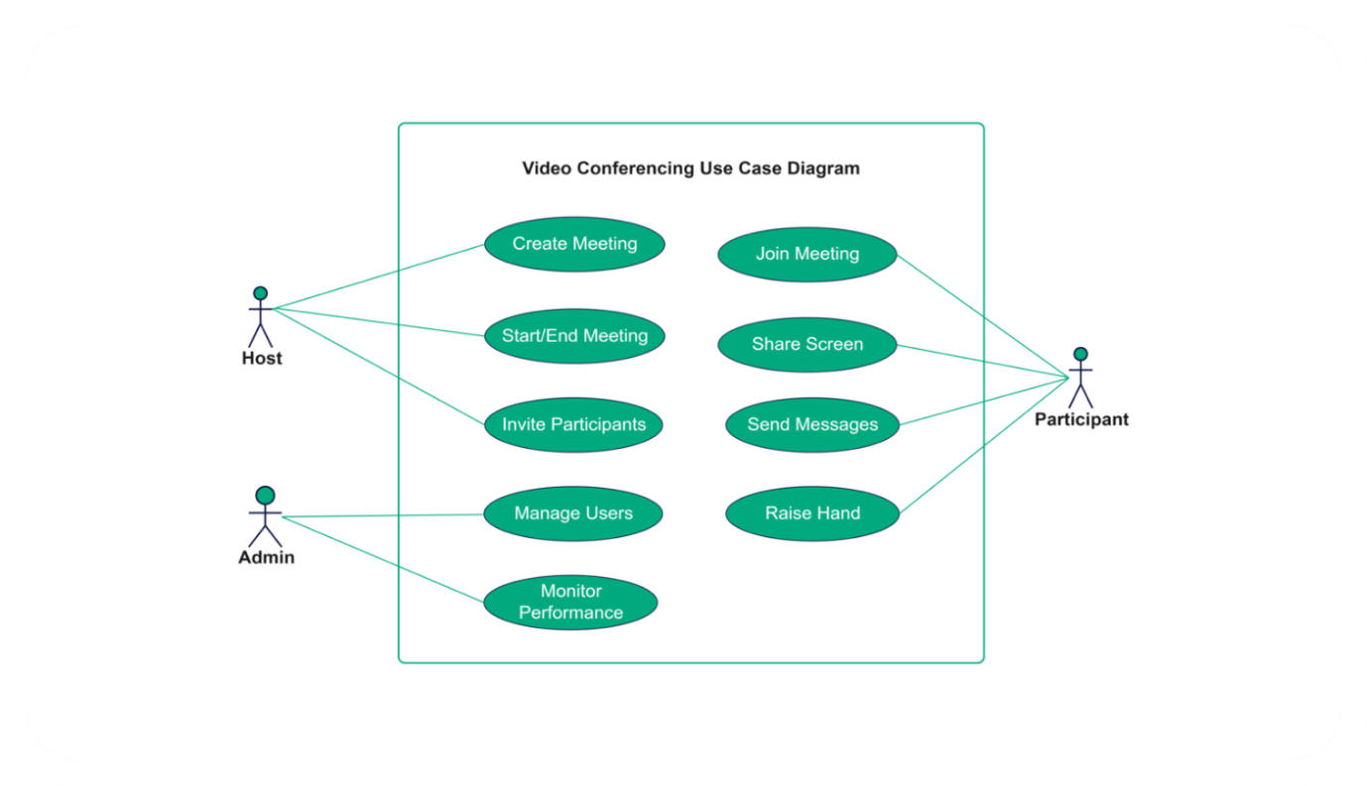
Reference: https://miro.com/templates/customer-problem-statement/

Problem Statement (PS) | I am (Customer) | I’m trying to | But | Because | Which makes me feel
PS-1 | a remote team member | join meetings on time and communicate effectively | current platforms have unstable audio/video and complex interfaces | connection drops and poor user experience | frustrated and unproductive
PS-2 | a team leader/host | manage participants and ensure smooth meetings | existing tools lack proper host controls and notifications | participants may interrupt or miss information | stressed and overwhelmed
PS-3 | a presenter | share my screen or content during meetings | screen sharing is limited or delayed on current platforms | cannot convey ideas clearly | anxious and unconfident
PS-4 | a participant | interact and ask questions during meetings | chat and messaging features are cumbersome or non-intuitive | communication is delayed or unclear | disconnected and disengaged

